Slate for Smart Boards — Upgrade Plan
Oct 30, 2026 · @Prism

Summary
Slate already has more teaching content than most smart-board apps; what it lacks is board-grade input handling and a teacher-first interface. The plan is to fix input first, then rebuild the shell around how a teacher stands at a 65–86 inch panel, then add classroom features.
What exists today (from the slate-web code): 13 pen types, 50+ 2D/3D shapes, shape and handwriting recognition, LaTeX formulas, ruler, protractor, reveal curtain, periodic table, maps, 3D solids, timer, stopwatch, dice, scoreboard, calculator, voice notes, flashcards, quizzes, mind maps, flowcharts, 8 backgrounds, pages, slide frames, presentation mode, minimap, find-on-board, PDF/document viewer, and an AI copilot with an offline fallback.
What changes on a smart board:
- The screen is huge and vertical. The teacher stands close, can't see the whole board, and the bottom and top edges are hard to reach for shorter teachers and students.
- Input is mostly fingers, passive styluses and palms, all reported as touch. Several people touch at once.
- The teacher is talking to 40 students while using it. Every action must work in one tap, readable from the back of the room, with no settings hunting.
- Boards run Android (Maxhub, BenQ, Samsung Flip, ViewSonic, Promethean) at 4K, often offline, shared by many teachers.

Phase 0: input blockers to fix first
The current input code assumes a phone or tablet with an active pen; on most smart panels it will misbehave the moment two hands touch the glass. These are the fixes, all in Canvas.tsx.
Issue found | Where | What happens on a board | Fix
Any 2nd touch starts pinch-zoom | onPointerDown (touchMapRef.size >= 2) and the native touchstart listener (e.touches.length >= 2) | Two students writing at once, or a resting palm, zoom the board and cancel the stroke | Per-pointer stroke sessions: each pointerId draws its own stroke. Zoom only on a deliberate 2-finger gesture that starts within ~80 ms and moves apart/together, or turn gestures off in a "Lock board" mode
Palm rejection needs pointerType === "pen" | Line 4666 | Boards report passive stylus and fingers as touch, so palm rejection never activates | Use contact size (e.width / e.height): small = pen/finger, large = palm. Make thresholds calibratable per board
No palm/fist erase | — | Teachers expect to wipe with the side of the hand (every IFP does this) | Contact area above a threshold switches to an object/pixel eraser sized to the contact, then back
Touch never gets pointer capture | Line 4686 | Fast strokes that leave the canvas element (over a widget or the toolbar) break | Capture all pointer types on the canvas; route widget hits explicitly
One global drawingRef | Canvas state | Only one stroke can be in progress at a time | Map of pointerId → drawing session; commit each independently to the store and undo stack
Single 7,450-line Canvas.tsx | — | Every board feature risks regressions | Split out input/ (pointer router, gesture detector, palm classifier) before adding features
Also check 4K performance: test a full board (1,000+ strokes) on a real 4K Android panel, render committed strokes to a cached layer, and keep only live strokes on the overlay canvas. Target 60 fps and under 20 ms pen-to-ink latency.

Teacher UX redesign
The goal is a board a first-time teacher can use in under a minute with no training: few visible choices, big targets, and everything reachable from where they stand.
A dedicated "Board mode" layout, switched on automatically when the screen is 55 inches or wider (or from Settings):
- Side docks, not a bottom-centre dock. Put a vertical toolbar on both left and right edges at mid-height, so the teacher reaches it from either side without walking across. Either dock can be hidden; both mirror the same tools.
- Five tools on the dock, not dozens. Pen, Highlighter, Eraser, Select, Shapes, then a "More" drawer. Pen opens 6 big colour swatches and 3 sizes. The 13 pen styles, 50 shapes and widgets live one level deeper.
- Big targets. Minimum 64 px touch targets (current buttons are 28–40 px), labels under icons, popovers at least 480 px wide instead of 356 px.
- Floating radial menu. Long-press anywhere on the canvas to open pen/colour/eraser/undo at the hand's position. No walking to a toolbar mid-sentence.
- Always-visible Undo, Redo, Clear and Page controls in a slim strip at the bottom corners, readable from the back of the room.
- Height-aware dialogs. Dialogs open near where they were triggered, never at the top of a 2-metre-tall screen. Add a "Pull down" button that moves the whole UI to the lower half for shorter teachers and students.
- Simple vs Advanced. A one-switch "Simple" mode hides AI, 3D, and pen effects for teachers who just want to write. Advanced shows everything.
Ease of understanding:
- Plain labels instead of jargon ("Glitter & Shine", "Radar Minimap", "Dual Ribbon" become "Sparkle pen", "Board map", "Double line").
- A 60-second first-run tour on the board itself, then a "?" button that shows labels over every control.
- Every destructive action is undoable; replace "swipe to clear" and "double-tap bin" with one Clear button plus an Undo toast.
- Settings grouped by teacher task (Writing, Pages, Classroom, Display), not by feature.

New features
The biggest gaps are multi-user writing, lesson prep and student interaction; Slate already covers content tools well. P1 = needed for a board release, P2 = strong differentiator, P3 = later.
Feature | What it does for the teacher | Priority | Effort
Classroom basics
Split board (2–4 zones) | Students solve side by side, each zone with its own pen, colour and undo | P1 | M
Multi-user writing | 2–10 people write at once anywhere on the board | P1 | M (after Phase 0)
Spotlight & screen shade | Dim everything except a movable circle/rectangle; extends the existing Reveal Curtain | P1 | S
Magnifier | Zoom lens on part of the board for the back rows | P2 | S
Freeze / Lock board | Stops accidental pans, zooms and erases while kids are at the board | P1 | S
Random name picker & groups | Load a class list once, pick a student or make groups on screen | P2 | S
Traffic light / noise meter | Classroom-management widgets next to the existing timer | P3 | S
Lesson preparation
Lesson files | A lesson = ordered pages + widgets, prepared at home on phone/laptop, opened on the board | P1 | M
Import PPT / PDF as pages | Annotate on top of existing slides (PDF viewer exists; make each page a board page) | P1 | M
Subject template packs | Maths graph paper, number lines, music staves, handwriting lines (4-line for Hindi/English), world/India maps | P2 | S
Page sorter | Thumbnail grid to reorder, duplicate and delete pages | P1 | S
Teaching tools
Graph plotter | Type y = f(x) and get an editable graph on the board | P2 | M
Compass & set-square | Join the existing ruler and protractor; ink snaps to the tool edge | P2 | M
Number line, fraction bars, clock | Draggable manipulatives for primary classes | P2 | S
Embedded video & web | Play a YouTube/local video or web page on a page and annotate over it | P2 | M
Desktop annotation overlay | Draw over any other Android app (needs a native Capacitor plugin) | P3 | L
Student interaction
Quick poll via QR | Students scan a QR, answer on their phones, results chart on the board (the qrcode package is already installed) | P2 | L (needs Supabase realtime)
Turn existing quiz objects into a live quiz | Reuse QuizObject; reveal answers and a class score | P2 | M
Drag-and-drop activities | Sort / match / label cards that students drag on the board | P2 | M
After class
Share notes via QR | Students scan to get the board as a PDF | P1 | M
Record lesson | Screen + voice recording saved as video | P3 | L
Auto-save & teacher login | Sign in with a QR from the teacher's phone; boards save to their account, not the shared device | P1 | M
AI (already strong)
Generate a lesson from a topic | Copilot builds 5–8 pages with diagrams, a quiz and flashcards | P2 | M
Board-friendly AI output | Answers rendered large and handwritten-style, placed where the teacher points | P2 | S

Roadmap
About 9–10 weeks of work gets a pilot-ready board build; each phase ends with a test on real hardware before the next starts.
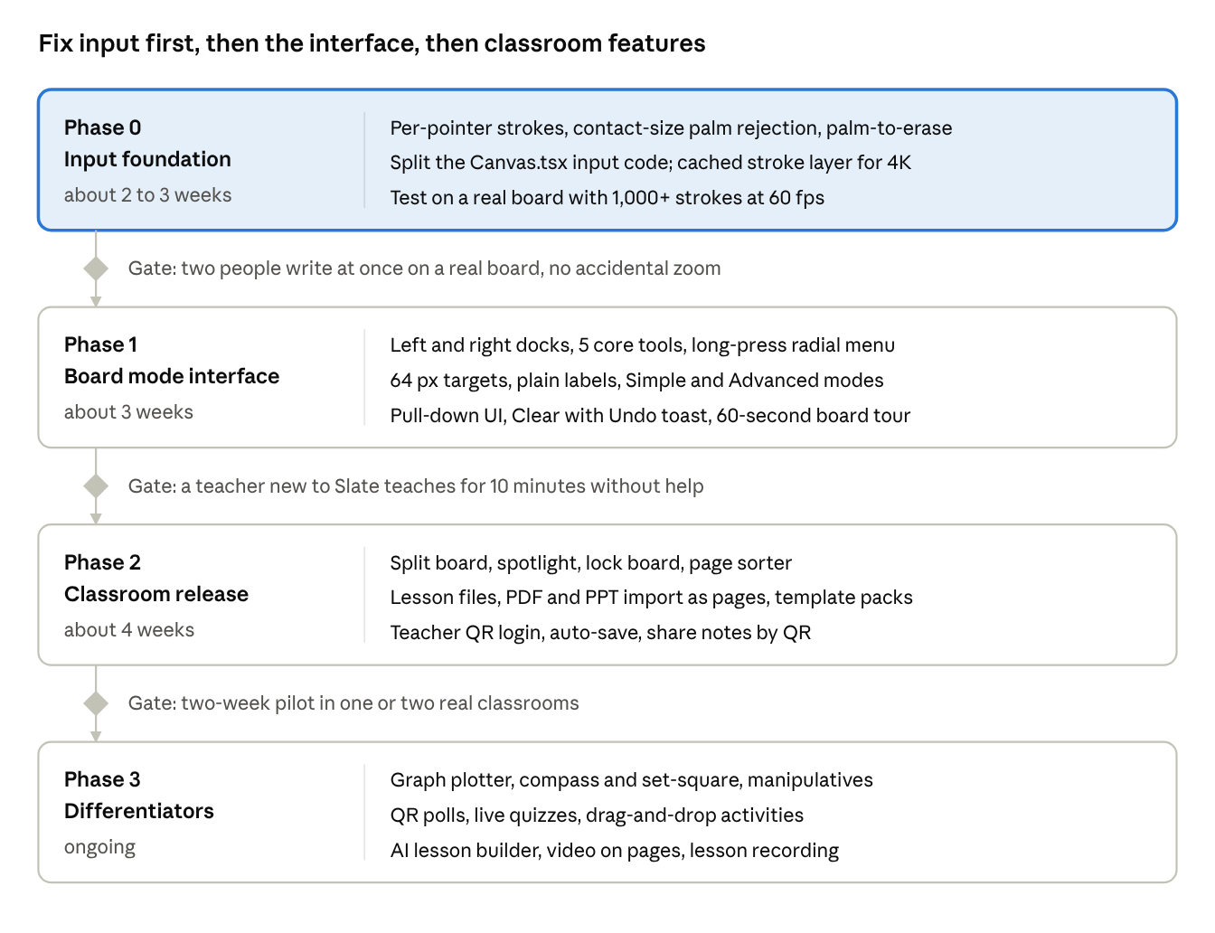
roadmap · 4 phases, 3 gates
Effort assumes one developer working full-time. Phase 3 items can be picked in any order based on pilot feedback.

Open questions
- ☐ Which board will this run on first (brand, size, Android version)? Contact-size palm detection must be tuned on real hardware.
- ☐ Does the board run Slate as an installed APK, or in a browser? This decides whether native features like the desktop overlay are possible.
- ☐ Who are the teachers: primary, secondary, or college? This sets which template packs and manipulatives come first.
- ☐ Will classrooms have reliable internet? If not, polls and sharing need a local-network fallback.
- ☐ Is the Play Store phone/tablet app still the same product, or does the board get its own build?

